SmartCare v0.4 - Domain Implementation Workbook
Week 7 student resource

1. UML-to-Code Trace
UML element | Python element | Implemented? | Notes
Patient class | class Patient | Yes | Core entity for storing patient data.
Patient.patient_id | self.patient_id | Yes | Unique identifier for each patient.
Patient.name | self.name | Yes | Patient’s full name.
Patient.dob | self.dob | Yes | Date of birth (stored as string for simplicity).
Patient.phone | self.phone | Yes | Contact phone number.
Patient.update_contact() | def update_contact(self,phone) |  | Updates the patient’s phone number.
Patient.get_appointment_history() | def get_appointment_history(self) | Yes | Returns a list of appointment IDs (delegated to ClinicSchedule).
Practitioner class | class Practitioner | Yes | Core entity for storing practitioner data.
Practitioner.practioner_id | self.practitioner_id | Yes | Unique identifier for each practitioner.
Practitoner.name | self.name | Yes | Practitioner’s full name.
Practitioner.specialty | self.specialty | Yes | Medical speciality.
Practitoner.update_availablity() | def update_availability(self,schedule) | Yes | Updates the practitioner’s availabilty
Practitioner.get_schedule() | def get_schedule(self, date) | Yes | Returns appoitnments for a given date.
Appointment class | class Appointment | Yes | Central linking class.
Appointment.appointment_id | self.appointment_id | Yes | Unique identifier for each appointment.
Appointment.date | self.date | Yes | Appointment date.
Appointment.time | self.time | Yes | Appointment time.
Appointment.status | self.status | Yes | “Booked”,”Cancelled”, or “Completed”
Appointment.cancel() | def cancel(self) | Yes | Changed status to “Cancelled”.
Appointment.is_duplicate() | def is_duplicate(self, practitioner, date, time | Yes | Checks for duplicate bookings.
ClinicSchedule | class ClinicSchedule | Yes | Coordinates bookings and reporting.
ClinicSchedule.book_appointment() | def book_appointment(self, patient, practitioner, date, time) | Yes | Core booking logic with duplicate check.
ClinicSchedule.cancel_appointment() | def cancel_appointment(self, appointment_id) | Yes | Cancels an appointment by ID.
ClinicSchedule.get_daily_report() | def get_daily_report(self,date) | Yes | Returns appointments for specific date.

2. Domain Invariants
Class | Invariant / rule | How protected
Patient | patient_id must be unique. | Checked in ClinicSchedule
Patient | name and phone must not be empty. | Validated in Patient._init_()
Practitioner | practitioner_id must be unique. | Checled in ClinicSchedule before adding a new practitioner.
Appointment | status must be one of: “Booked”, “Cancelled”, “Completed”. | Validated in Appointment._init_() and cancel()
Appointment | A cancelled appointment cannot be cancelled again. | cancel() checks if status is already “Cancelled”.
ClinicSchedule | No double-booking: a practitioner cannot have two appointments at the same date and time. | book_appointment() checks is_duplicate() before creating.
ClinicSchedule | No double-booking: a patient cannot have two appointments at the same date and time. | book_appointment() checks for patient clashes.
ClinicSchedule | New appointments must be in the future. | book_appointment() compares date/time to current time.

3. Composition / Inheritance Decisions
Relationship | Decision | Rationale
ClinicSchedule→Appointment | Aggregation (ClinicSchedule “has” Appointments) | The ClinicSchedule manages a collection of Appointments. An Appointment can exist independently (e.g., for historical records) even if removed from the schedule.
Appointment→Patient | Association | An Appointment references a Patient but does not own it. A Patient can exist without any appointments.
Appointment→Practitioner | Association | An Appointment references a Practitioner but does not own it. A Practitioner can exist without any appointments.
No inheritance used | N/A | There is no “is-a” relationship between my classes. All relationships are “has-a” or “uses-a”. This keeps the design simple and avoids unnecessary complexity;

Lab/Python Activity – Evidence
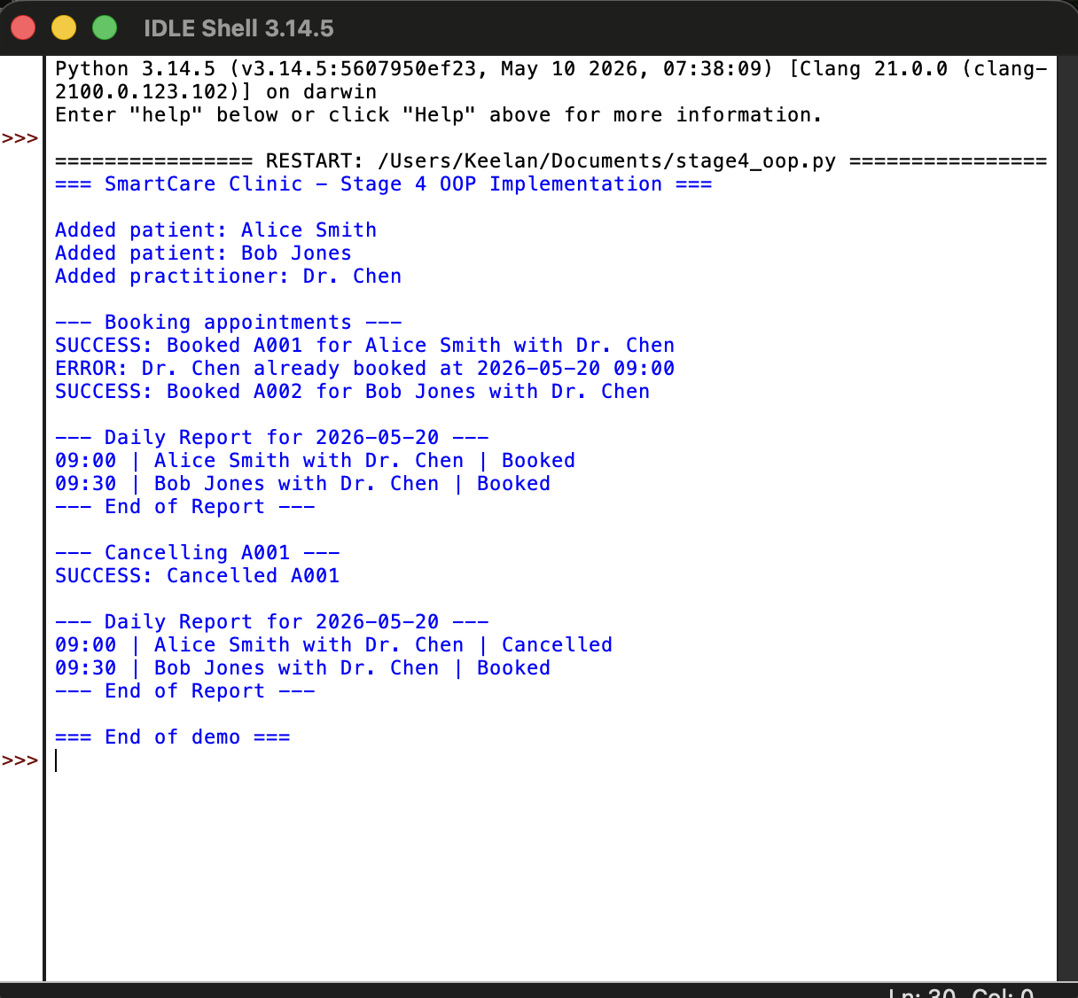
Stage 4 OOP implementation executed successfully via stage4_oop.py. Implements FR-06 (book appointment), FR-07 (prevent duplicate bookings), FR-08 (cancel appointment), and FR-12 (daily report). Output confirms the duplicate prevention logic works and cancellation updates the appointment status.

4. AI Pair-Programming Record
AI contribution | Conforms? | Decision | Reason | Verification
Suggested adding type hints (str,int) to function parameters. | Yes | Accept | Improves code readability and helps catch errors early. | Tested in Python 3.10+, works fine.
Suggested using datetime module for date validation. | Yes | Accept | Prevents invalid dates like “32/13/2026”. | Tested with normal and invalid inputs.
Suggested making ClinicSchedule a Singleton to ensure only one schedule exists. | Yes | Reject | For a simple clinic system, a Singleton adds unnecessary complexity. A single instance in main() is sufficient. | Checked requirements – no need for global state.
Suggested adding a reschedule() method. | Yes | Reject | Rescheduling is not in the Stage 2 Requirements. Kept out of scope to stay on track. | Compared with FR-01 to FR-12; no rescheduling requirement.
Suggested validating that appointment time is within practitioner availability. | Yes | Modify | I added a placeholder comment for this, but full implementation requires availability data no yet defined. | Noted as an open question from Stage 2.

5. Updated UML
No changes were made to the UML from Stage 3. The implementation matched the design exactly.

